Name of Student: Harpal Bidawat | PRN:25070122080
Semester: III | Year: AY 2026-27
Subject: Programming with Java
ASSIGNMENT No: 30
TITLE: Write a JSP application to demonstrate CRUD operations.
Problem Statement
Write a JSP application to demonstrate CRUD operations.
Learning Objectives
To implement Create, Read, Update, and Delete operations using JSP and a database.
Programme
1. Create a JSP-based application to add, update, delete, and view employee details
2. Create a JSP-based application to manage patient records using CRUD operations. Include fields such as patient ID, name, age, disease, and treatment status.

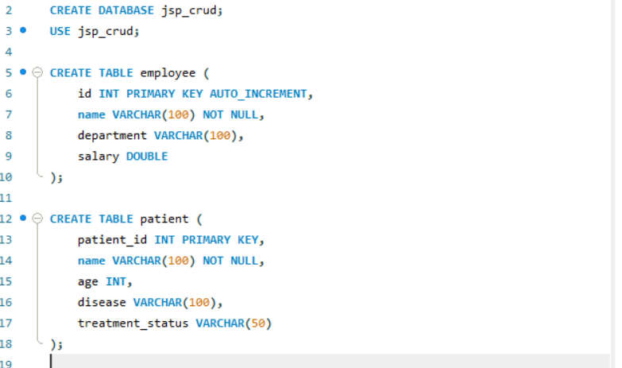
Employee.jsp
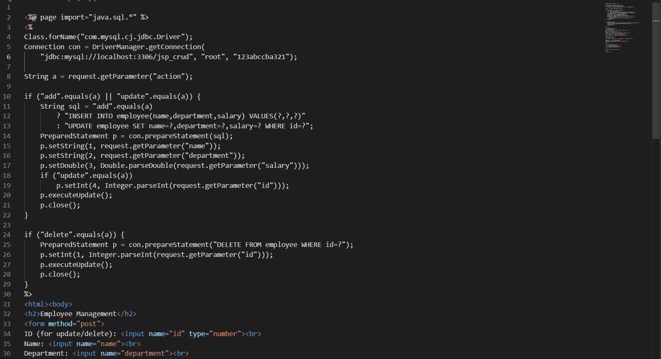
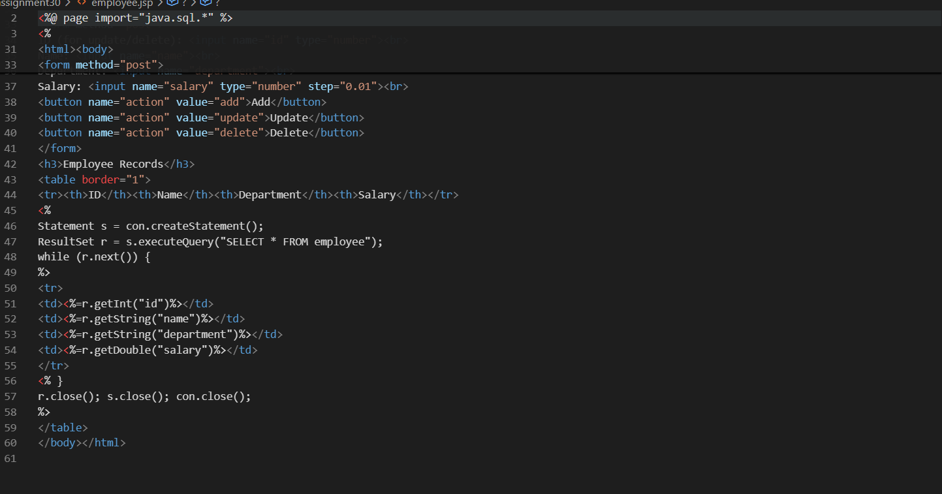
Patient.jsp
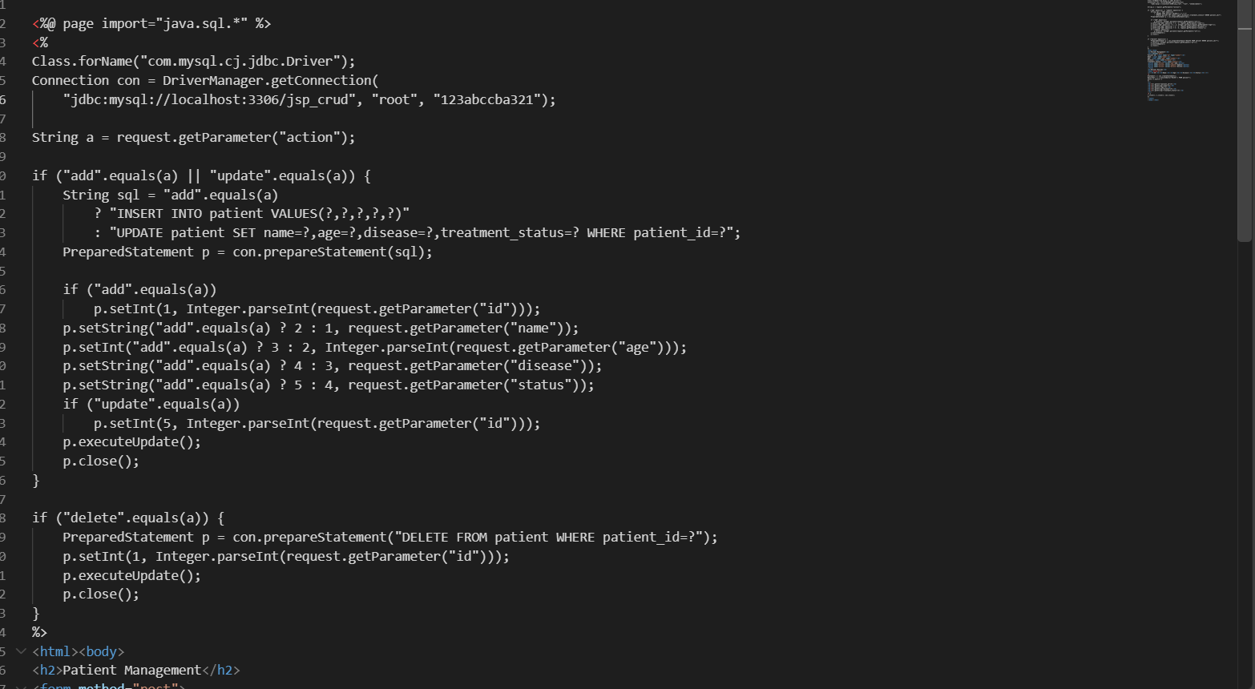
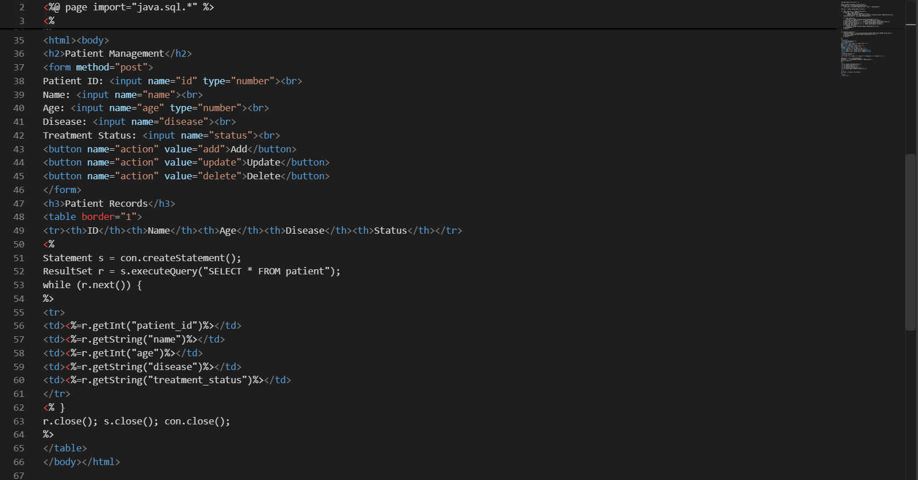
Output

Conclusion
JSP-based application was successfully implemented to perform CRUD operations on records using Java, JSP, and MySQL. It demonstrated database connectivity, insertion, retrieval, updating, and deletion of records through a web interface.

